Circuit Analysis (Lab10)

Experiment 9: Verification of Thevenin’s Theorem

Name: Momna Ashraf Registration No: 2025-CE-72 Date: 11-05-2026 Grade and Signature: ……………………
CLO2 CLO3 | Use with identification the circuit components, breadboards, multimeter, power supplies, signal generators, and oscilloscopes. Make measurements in their own constructed electric circuits.
Psychomotor/Affective | Level1  (1) | Level2 (2-3) | Level3 (4-5) | Level4 (6-7)
Report Marks (3)
 | Total marks (10)

Objective
The objective of this lab is verify Thevenin’s theorem and to find the full load current.

Apparatus Required
Sr. no | Apparatus | Range | Quantity
1 | Regulated Power Supply | Standard | 1
2 | Signal Generator | Standard | 1
3 | Oscilloscope | Standard | 1
4 | Digital Multimeter | Standard | 1
5 | Breadboard & Wires | Standard | As Required
6 | Resistors | 1k, 330 ohms | 1,3
7 | Potentiometer | Standard | 1

Description

Statement:
Any linear bilateral, active two terminal network can be replaced by an equivalent voltage source (VTH). Thevenin’s voltage or V OC in series with looking pack resistance RTH.

Precautions:
- Voltage control knob of RPS should be kept at minimum position.
- Current control knob of RPS should be kept at maximum position

Procedure:
- Connections are given as per the circuit diagram.
- Set a particular value of voltage using RPS and note down the corresponding ammeter readings. To find VTH 3. Remove the load resistance and measure the open circuit voltage using multimeter (VTH). To find RTH
- To find the Thevenin’s resistance, remove the RPS and short circuit it and find the RTH using multimeter.
- Give the connections for equivalent circuit and set VTH and RTH and note the corresponding ammeter reading. 6. Verify Thevenins theorem.

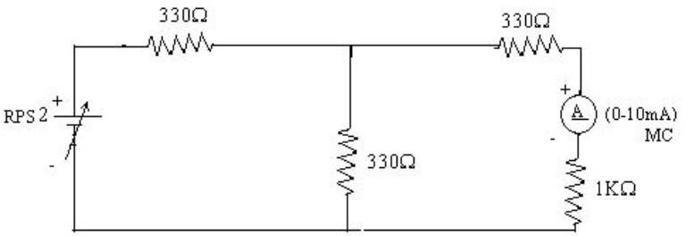
Circuit - 1: To find load current

To find VTH
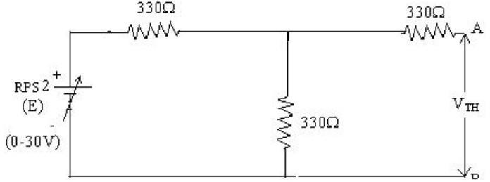

To find RTH
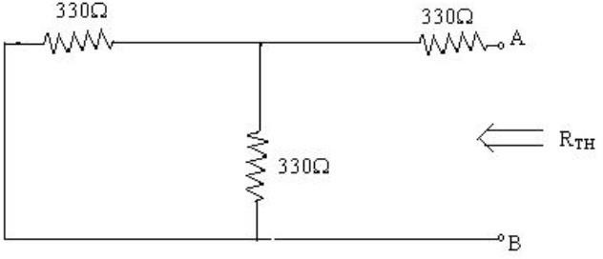

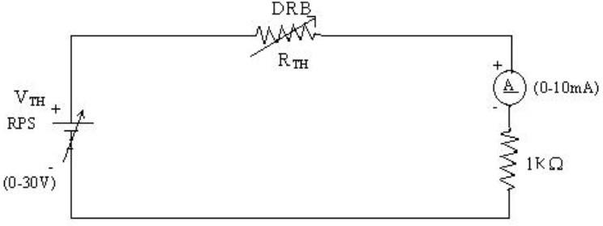
Thevenin’s Equivalent circuit:

Thevenin Practical Values

 | E(V) | VTH(V) | RTH(ohms) | IL (mA)
 |  |  |  | Circuit - I | Equivalent Circuit
Values | 10V | 5V | 495(ohms) | 3.34mA | 6.69mA

Post Lab Questions

1. What is Thevenin’s Theorem?
Thevenin’s Theorem states that any linear bilateral electrical network containing voltage sources, current sources, and resistances can be replaced by an equivalent circuit consisting of a single voltage source (in series with an equivalent resistance .
The Thevenin voltage is the open-circuit voltage across the load terminals, while the Thevenin resistance is the resistance seen from the load terminals after removing all independent sources. Voltage sources are short-circuited and current sources are open-circuited.
This theorem simplifies the analysis of complex circuits, especially when studying the effect of different load resistances.

2. What are the applications of Thevenin’s Theorem?
- It is used to simplify complex electrical circuits into simple equivalent circuits.
- It helps in analyzing circuits with varying load resistances.
- It is useful for calculating current, voltage, and power in a specific branch of a network.
- It is widely used in electronic circuit design and troubleshooting.
- It helps in maximum power transfer analysis.
- It is used in communication systems and power systems for easier circuit analysis.
- Engineers use it to model practical voltage sources.
- It reduces lengthy mathematical calculations in network analysis.

3. What are the theoretical and practical limitations of Thevenin’s Theorem?
Theoretical Limitations:
- Thevenin’s Theorem is applicable only to linear and bilateral networks.
- It cannot be directly applied to nonlinear elements such as diodes and transistors operating in nonlinear regions.
- The theorem is mainly valid for steady-state circuit analysis.
Practical Limitations:
- Finding Thevenin equivalent resistance and voltage may become difficult in highly complex circuits.
- Dependent sources require special treatment and cannot simply be removed while calculating .
- The process becomes time-consuming for large practical networks.
- It does not provide detailed internal behavior of the original circuit after simplification.

